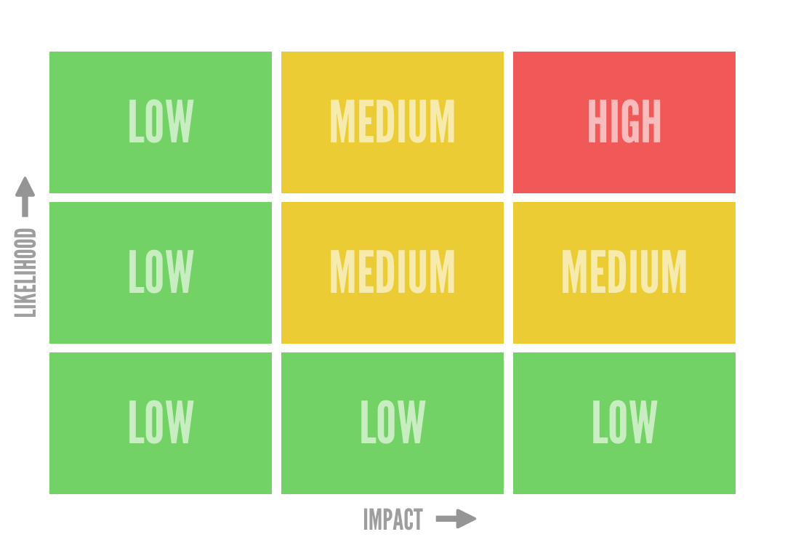

Risk Assessment

Event –

Completed by –

Date –

Reviewed -

|  |  |  |  |  |  |
| --- | --- | --- | --- | --- | --- |
| Hazard | Potential  Harm | Risk from Matrix | Control | Residual  Risk | Continue/  Discontinue |
|  |  |  |  |  |  |
|  |  |  |  |  |  |
|  |  |  |  |  |  |
|  |  |  |  |  |  |
|  |  |  |  |  |  |
|  |  |  |  |  |  |
|  |  |  |  |  |  |
|  |  |  |  |  |  |
|  |  |  |  |  |  |
|  |  |  |  |  |  |
|  |  |  |  |  |  |
|  |  |  |  |  |  |
|  |  |  |  |  |  |
|  |  |  |  |  |  |